United Way of Cass County
Invites you to our annual

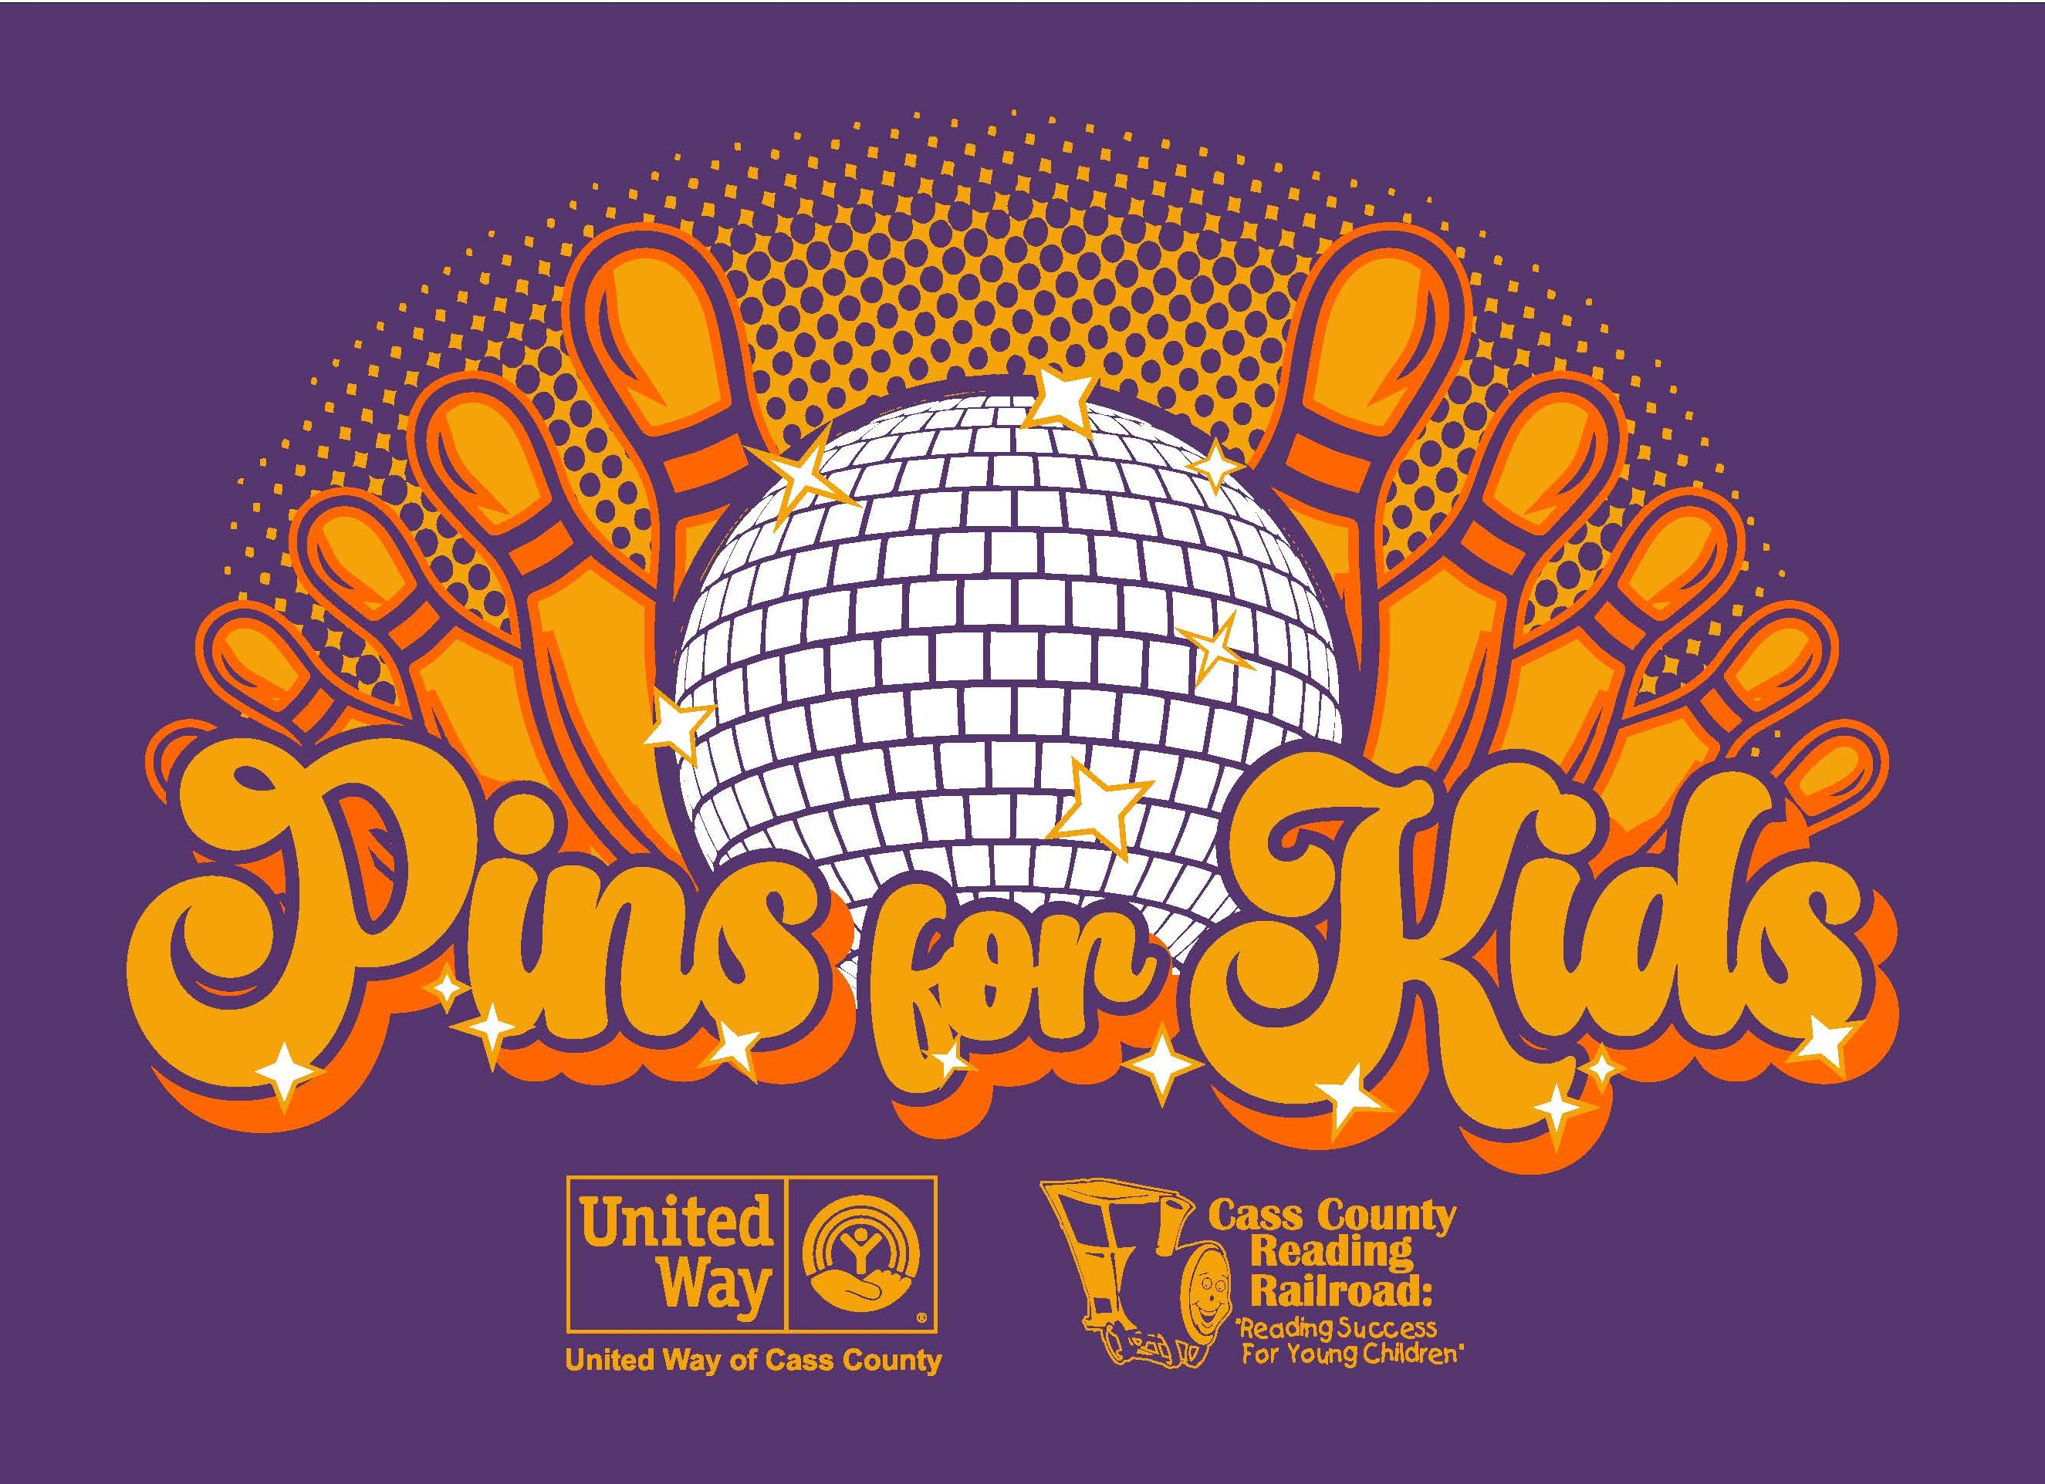

To Benefit Cass County Reading Railroad

Saturday, March 4, 2023 9:00 AM – 3:00 PM Myers Sport Bowl

Team Registration: Cost per team (5 bowlers) is $175

Team Name: __________________________________

Time Preference 1st choice Bowling start times:
2nd choice 9:00, 10:15, 11:30, 12:45, 2:00
3rd choice

Register by February 3rd^{th} to receive a FREE T-shirt!! After this date shirts are not guaranteed.
All shirts are short sleeve. Adult - S, M, L, XL, 2X, 3X, 4X Youth - M, L

Please Print

Team Captain Phone: __________________________________ Shirt Size: _____

Address: _________
Street Address City State Zip
Employer: Email:____________________________________________

Bowler 2 ___ ____ Email:______________________________________ Shirt Size:

Bowler 3 ___________ Email: ______________________________________ Shirt Size:

Bowler 4 __ ____ Email: ______________________________________ Shirt Size:

Bowler 5 ___________________ Email: ______________________________________ Shirt Size:

License #15524

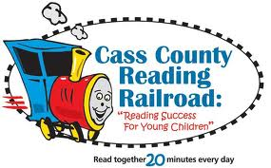
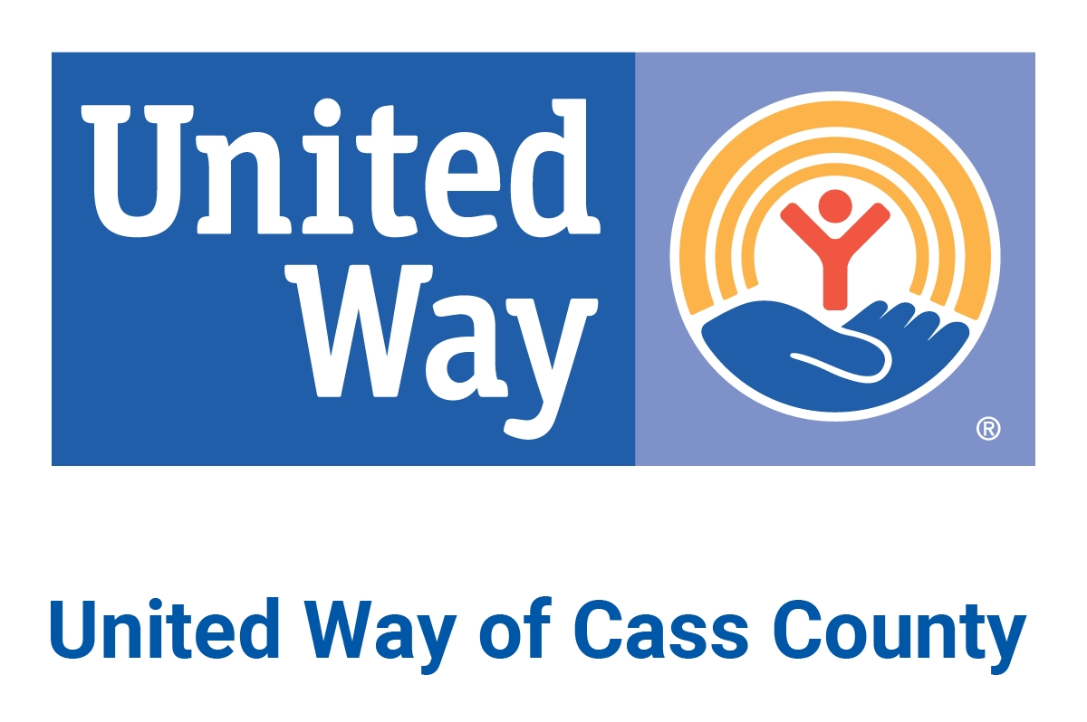
Please return to:
United Way of Cass County
300 E. Broadway; Suite 101 Logansport, IN 46947
574-753-3533 | karmstrong@unitedwayofcasscounty.org

