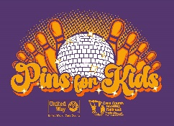

United Way of Cass County
Pins for Kids Event
To Benefit Cass County Reading Railroad

Saturday, March 4, 2023 9:00 AM – 3:00 PM Myers Sport Bowl

Business Name: ___________________________ Contact:___________________

Phone: _________________

Door Prize Description: _______________________________________________

Estimated value of item: $_____________

Method of delivery:
____ I will mail/drop off donation to United Way by February 17th

____ Please pick up my donation

If you have any questions, please give us a call at 574-753-3533 or email
karmstrong@unitedwayofcasscounty.org

Thank you for your support!

United Way of Cass County &
Cass County Reading Railroad

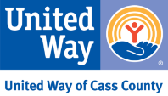
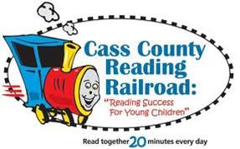
License #15524

