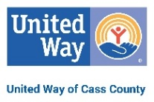
2022 LIVE UNITED® Sponsor

The LIVE UNITED® t-shirt is more than just a shirt; it is a way of life. As a sponsor of LIVE UNITED® Day, your company’s name will be printed on the back of approximately 500 shirts to be given to volunteers at events such as the Campaign Rally, LIVE UNITED® Day, and the 2022 Campaign Cabinet!
___ Yes, I would like to LIVE UNITED® and sponsor! Deadline: May 16th
This is the date we need your form back. Payment can be made later.

Organization: __________________________________________________________
Name on Shirt (if different): _______________________________________________
Mailing Address: _______________________________________________________
Email Address: ________________________________________________________
Phone Number: _________________ Contact Person:________________________

Benefits of Sponsoring: Company name will appear on the shirts for the largest volunteer event of the year in Cass County, be recognized in the newspaper and at the LIVE UNITED® Day kick off. If sponsoring at $300 and up you will also be recognized in LIVE UNITED® Day promotions such as newspaper, radio and social media. Help us provide a t-shirt to every volunteer!

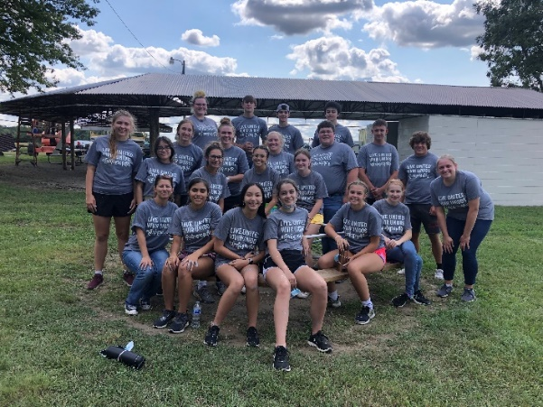
Sponsorship Amount: __ $150 – Name in small print
__ $300 – Name in next largest print
__ $500 – Name in next largest print
__ $750 – Includes company logo instead of name
__ Other: ____________

Payment Options:
__ Check Enclosed (Payable to: United Way of Cass County)
__ Invoice Me
Please return form to: United Way of Cass County, 300 E. Broadway; Suite 101, Logansport, IN 46947. Email Karli Armstrong karmstrong@unitedwayofcasscounty.org or call 574-753-3533 with any questions! Thank you for your support!
Great Things Happen When We LIVE UNITED®!

