**2024 LIVE UNITED® Sponsor**

The LIVE UNITED® t-shirt is more than just a shirt; it is a way of life. As a sponsor of LIVE UNITED® Day, your company’s name will be printed on the back of over 500 shirts to be given to volunteers at events such as the Campaign Rally, LIVE UNITED® Day, and the 2024 Campaign Cabinet!

___ Yes, I would like to LIVE UNITED® and sponsor! **Deadline: July 31st**

**This is the date we need your form back. Payment can be made later.**

Organization: __________________________________________________________

Name on Shirt (if different): _______________________________________________

Mailing Address: _______________________________________________________

Email Address: ________________________________________________________

Phone Number: _________________ Contact Person:________________________

**Benefits of Sponsoring:** Company name (or logo) will appear on the shirts for the largest volunteer event of the year in Cass County, and sponsors will be recognized at the LIVE UNITED® Day kick off. Help us provide a t-shirt to every volunteer!

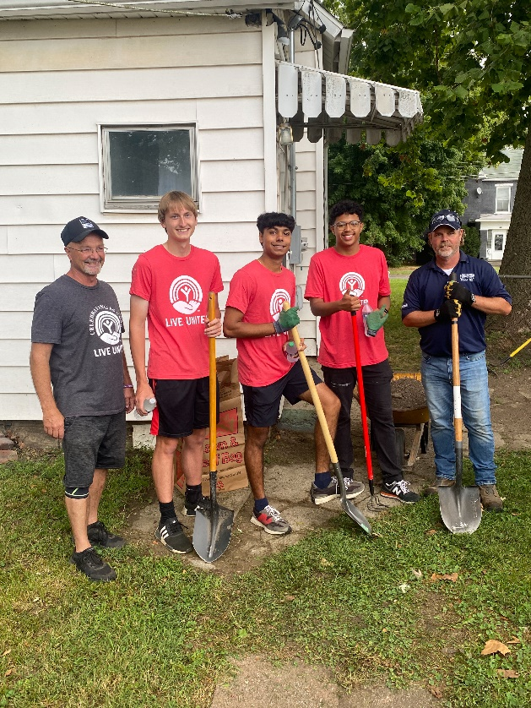

**Sponsorship Amount:**

**__** **$150** – Name in small print, social media recognition

**__** **$300** – Name in next largest print, social media recognition, included in Thank You ad

**__ $500** – Name in next largest print, social media recognition, included in Thank You ad

**__ $750** – Includes company logo instead of name, individual social media recognition, included in Thank You ad  
**__ Other:** ____________

**Payment Options:**

**__** Check will be mailed (Payable to: United Way of Cass County)

**__** Invoice Me

**Please return form to:** Karli Armstrong at [karmstrong@unitedwayofcasscounty.org](mailto:karmstrong@unitedwayofcasscounty.org) or United Way of Cass County, 300 E. Broadway; Suite 101, Logansport, IN 46947. Email Karli or call 574-753-3533 with any questions! **Thank you for your support!**

**Great Things Happen When We LIVE UNITED®!**